Walkthrough 6 Modules

<https://sapui5.hana.ondemand.com/#/topic/f665d0de4dba405f9af4294de824b03b>

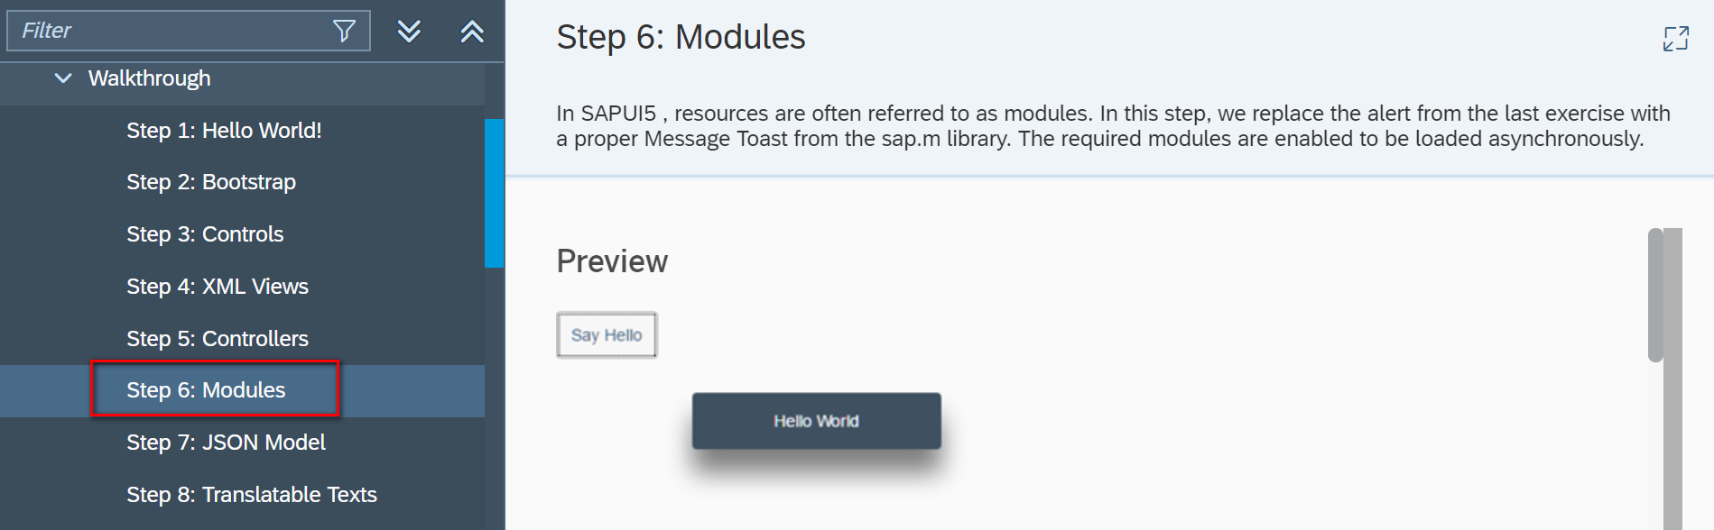

Core Codes:

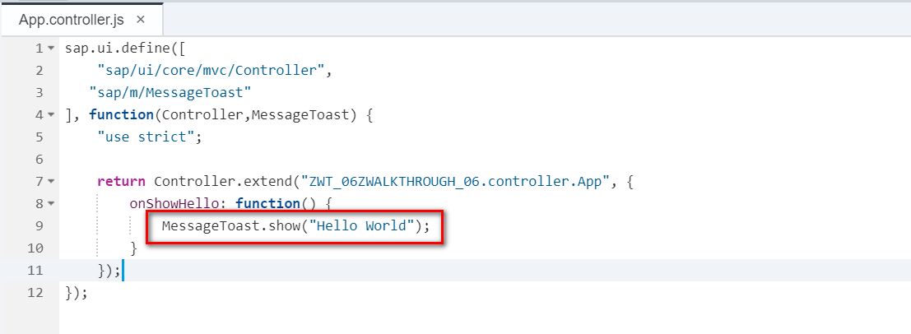

Git:

Result:

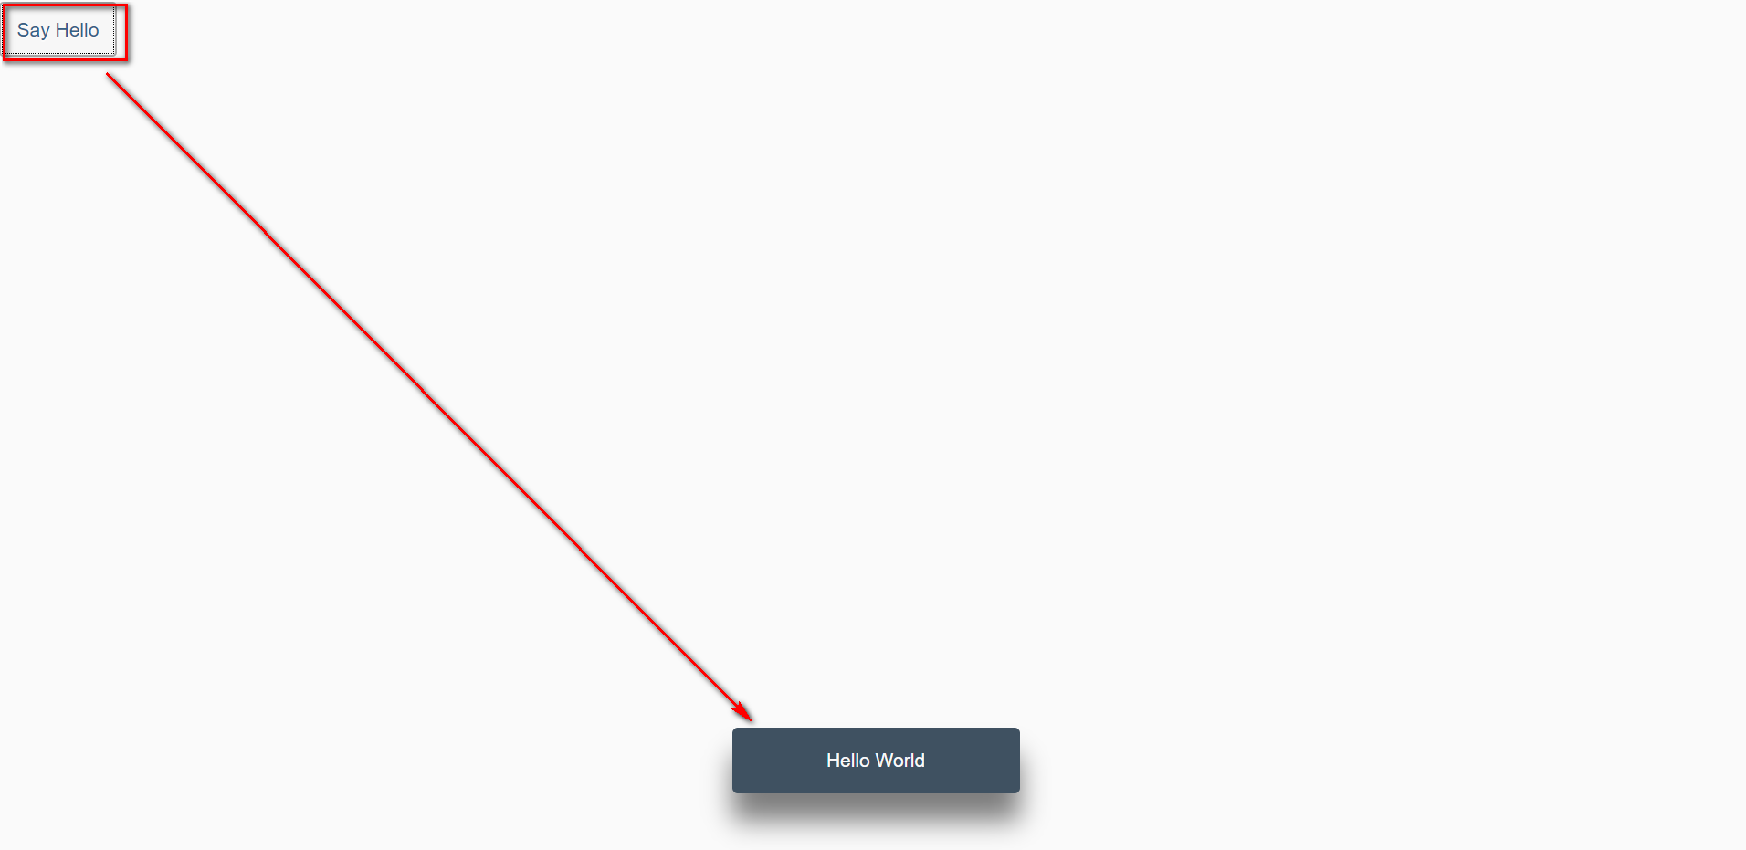

2018/11/02 XiaoMi Beijing Zac,Xie